**THE DESIGN AND IMPLEMENTATION OF AN E-COMMERCE SITE FOR ONLINE DARAZ E - SHOPPING**

**BY**

**Bazia Azmat (017)**

**Farrukh Khan (031)**

**Rabbiya Jahangir (018)**

**Project Report Submitted to the faculty of the University.**

**in Partial Fulfilment OF the requirement for the degree**

**BS In Computer Engineering**

**Department of Computer Engineering Of KICSIT**

**January 2024**

**Faculty Member**

**Ayesha Khanam**

**All Rights Reserved**

#### Abstract

The business-to-consumer aspect of electronic commerce (e-commerce) is the most visible business use of the World Wide Web. The primary goal of an e-commerce site is to sell goods and services online.

This project deals with developing an e-commerce website for Online Book Sale. It provides the user with a catalo of different books available for purchase in the store. In order to facilitate online purchase a shopping cart is provided to the user. The system is implemented using a 3-tier approach, with a backend database, a middle tier of Microsoft Internet Information Services (IIS) and ASP.NET, and a web browser as the front end client.

In order to develop an e-commerce website, a number of Technologies must be studied and understood. These include multi-tiered architecture, server and client side scripting techniques, implementation technologies such as ASP.NET, programming language (such as C,PHP, bootstrap, Html, CSS), relational databases (such as MySQL, Access).

This is a project with the objective to develop a basic website where a consumer is provided with a shopping cart application and also to know about the technologies used to develop such an application.

This document will discuss each of the underlying technologies to create and implement an e-commerce website.

**Literature Review**

Electronic Commerce (e-commerce) applications support the interaction between different parties participating in a commerce transaction via the network, as well as the management of the data involved in the process [2].

The increasing importance of e-commerce is apparent in the study conducted by researches at the GVU (Graphics, Visualization, and Usability) Center at the Georgia Institute of Technology. In their summary of the findings from the eighth survey, the researchers report that “e-commerce is taking off both in terms of the number of users shopping as well as the total amount people are spending via Internet based transactions”.

Over three quarters of the 10,000 respondents report having purchased items online. The most cited reason for using the web for personal shopping was convenience (65%), followed by availability of vendor information (60%), no pressure form sales person (55%) and saving time (53%).

Although the issue of security remains the primary reason why more people do not purchase items online, the GVA survey also indicates that faith in the security of ecommerce is increasing. As more people gain confidence in current encryption technologies, more and more users can be expected to frequently purchase items online [11].

A good e-commerce site should present the following factors to the customers for better usability [11]:

Another important factor in the design of an e-commerce site is feedback [4]. The interactive cycle between a user and a web site is not complete until the web site responds to a command entered by the user. According to Norman [5], "feedback--sending back to the user information about what action has actually been done, what result has been accomplished--is a well known concept in the science of control and information theory. Imagine trying to talk to someone when you cannot even hear your own voice, or trying to draw a picture with a pencil that leaves no mark: there would be no feedback".

Web site feedback often consists of a change in the visual or verbal information presented to the user. Simple examples include highlighting a selection made by the user or filling a field on a form based on a user's selection from a pull down list. Another example is using the sound of a cash register to confirm that a product has been added to an electronic shopping cart.

**Chapter 1**

**INTRODUCTION**

This is the first phase of the System Development Life Cycle. This phase is very important because in this phase I will get to know the organisation behaviour for which I’m doing my project.

I have visited few super shops. Some of them are maintaining manual system, but they are not in very much huge company but large super shops are maintaining Point of Sale (POS) System. I find that every manual system has lacking and problems in their system. In this age of IT, now it is no more possible to maintain manual systems in organisation moreover a super shop must use POS for quick access of data and for become faster in service. So I’ll like to develop a system for those super shops that are not using POS yet.

Initial investigation is the phase, where we will understand what we have to do in this project. We will determine hare, what about the project is? What the project need, what is current status of the project and what are the problems with the current system. As I am going to develop a general system, so I will use strategies of several companies and generates a single solution.

* 1. **Needs Identification**

The proposed system includes three sections:

1. Admin
2. Employee
3. Registered/Unregistered Customer sections.

Each section has specific functionalities and features, such as managing products, sales, purchases, administration, scratch cards, and user account settings.

**1.2 Determining User Requirements**

All POS’s are almost same. But several POS’s gives several kinds of facilities. When I talk with POS users, they told me to organize the system simply. Supplier Information, Customer Information & Product Information are very simple. But Product Purchase Information, Auto Stock Update, Invoice Printing & Management Section should have a simple view & easy maintenance process.

They also require strong Security in the system. Every employee should have password & Admin of the system will decide their access limit.

**1.3 Problem Identification:**

It is proven that human can’t work as computer. So it is 99.99% possible where manual system will continue, there would be some lacking & problem with the system.

I have seen some problems in the above systems which can categories in three parts. These are:

**01) General Problem**

1. Needs moor time to searching old files.
2. For preparing a suitable report it needs to work with 4/5 files at a time for necessary information which also take moor time.
3. The productivity of the human resource can raised by couple of times if this manual system can be changed into a computerized system.
4. It is so problematic to write a sales invoice if customer buy a lot of small things.

**02) Technical Problem**

1. It need moor place to store the old files.
2. Some time files may be destroyed by cockroach or by another way.
3. It is unsecured.
4. There is not any strong stock control.

**03) Financial Transaction**

1. It is so time consuming to get daily sales report
2. Some time calculation may wrong

The author aims to address these problems through the development of a computerized POS system that caters to the specific needs of super shops, particularly those that are not as large as major super shops but still require efficient management solutions.

**Chapter 2**

**Feasibility Study**

Feasibility study is the second phase of the System Development Life Cycle. But in wide seance, feasibility study is a cross life cycle activity and should be continuously performed throughout a system project.

A feasibility study is a preliminary investigation of a proposed system to decide whether the system can run smoothly with the organization, will the organization realize the benefits that are expected and to decide will the organization go for it.

Some time it is criticized that feasibility study makes delay starting of the system, but it is an important subject to think that some peoples this thought may harmful for the organization. If the system is of low cost and low risk from the organization’s point of view, then they can minimize it. But this is not a good idea for larger system because this may risky for them and they have also to determine the cost justification for the system.

**2. 1 Stages of Feasibility Study**

Feasibility study and feasibility analysis has defined. But there is also four categories of feasibility recognized by the analysts. Those are:

* + Operational feasibility
  + Technical feasibility
  + Schedule feasibility
  + Economical feasibility

But we are going to discuss with just Technical & Economical feasibility.

* **Technical feasibility**

looks at the system in point of view, is the system practical, do we have the technical support, that we could maintain the system, and is it reasonable? In case of my system, answers to these questions are:

* **Practicality**

Normally all provided solutions are available in market. Now the question is, wither the technology is mature enough to solve our problem. In this case, I’ll say, this system determined to design in a way, that could solve maximum problem’s of POS. In this way, I’ll say, this system is practical for any POS.

* **Current Technology**

In case of current technology, that will need to run the system is a Pentium IV PC for Server, Pentium III PC’s for client and any printer that could print A4 size paper. And all of this are available in market.

* **Reasonability:**

All hardware’s and PC’s must be reasonable to the company who is running a POS. The cost of “POS System” is also reasonable. A lot’s of un-employed people are available and people who want a part-time / full-time job. So where everything that needs to run the system is reasonable we could say, the system is reasonable.

All answers are found positive hear, so we could say, the system is Technically feasible.

Economical feasibility is a measure of the cost-effectiveness of a project or solution.

System cost can be defined in earlier stages of system development. Though this is a general system, a cost plane is identified. The cost plan is divided in two phase:

* + Cost of development;
  + Cost of using the system
* **Cost of Development**

In cost of development, programmers, analyst other peoples salary who are related in development. Again cost’s of computer, hardware, testing, training etc are involved. But system development cost is just onetime cost, which will not recur after the project has been developed.

* **Cost of using the system**

Cost of using the system is pre defined and in some times it’s depends on user. Cost of using a system can be divided in two ways. Fixed cost and variable cost.

Fixed cost: Software purchase cost & license cost are fixed.

* Salaries of system operation are fixed, but it depends on client software also.
* Variable cost: Variable costs are:
* Cost of computer use
* Suppliers e.g. printer, paper, magnetic tapes, floppy disks.

**2.2.1 Objective of the System**

Objective of the system is to cover all events that are related to a supper shop. Events, which are aimed to cover in this system, are:

· A central server, in case of having moor branch of a shop. This central server will generate same product id for each branch.

* + A server, for each shop.
  + A client for each sales point.
  + Stock of each branch.
  + Auto invoicing system.
  + All kinds of text & graphical report.

**2.2.2 Boundary**

Every system has a boundary and that can not cover everything of an organisation. This system is just dealing with sales system, and could not perform anything else of the organisation, like attendance, payroll, leave monitoring etc.

**Chapter 3**

**Requirement Analysis**

Requirement Analysis is the third step of System Development Life Cycle (SDLC) and my project also. This stage is very much important and inseparable part of a project.

Requirement Analysis is concerned with discovering and deciding what the new system is required to do? I have discovered and find out some outline from the Initial Study and Feasibility Study of my project, but those are not enough to start building a new system.

**3.1Fact Finding**

Fact-finding is one of the important steps toward any system development. It is essential to gather all the information and facts about an existing system to ensure that all strengths and weakness are discovered. Thus when a new system is designed as many of the weaknesses as possible are eliminated, whilst retaining the strengths. There are five general techniques available; those used depend upon the particular circumstances!

**3.2Project Design**

In order to design a web site, the relational database must be designed first. Conceptual design can be divided into two parts: The data model and the process model. The data model focuses on what data should be stored in the database while the process model deals with how the data is processed. To put this in the context of the relational database, the data model is used to design the relational tables. The process model is used to design the queries that will access and perform operations on those tables.

**3.3Data Model**

A data model is a conceptual representation of the data structures that are required by a database. The first step in designing a database is to develop an Entity-Relation Diagram (ERD). The ERD serves as a blue print from which a relational database maybe deduced. Figure 1 shows the ERD for the project and later we will show the transformation from ERD to the Relational model.

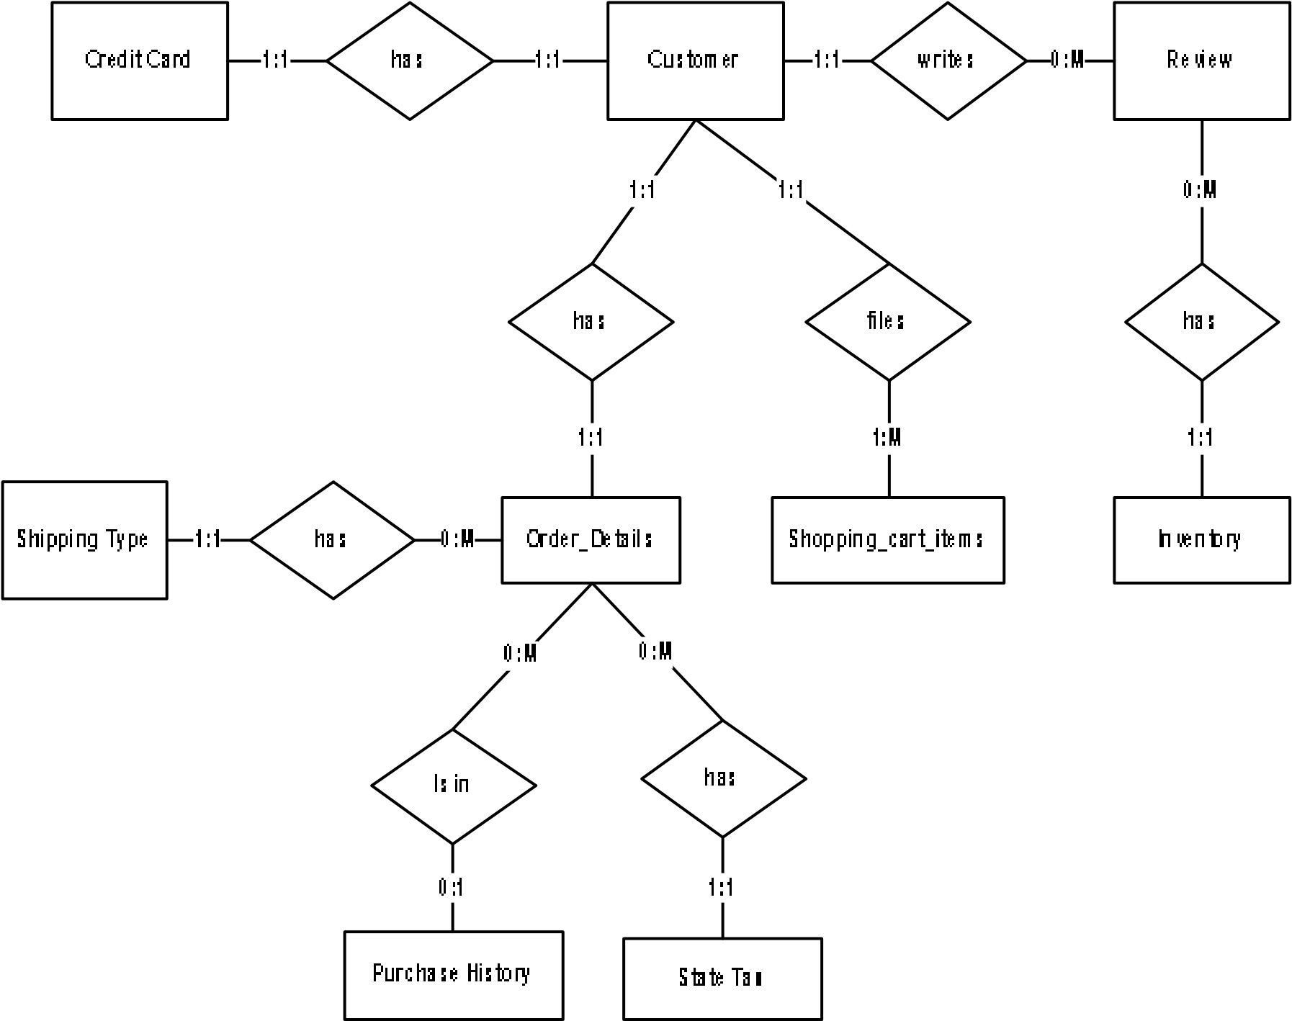

**3.3.1Project scope**

The project is to develop a custom website where electronic products can be sold online. Administrator, will be responsible for managing the products details and the users. In the case customers from the web based backend panel. The development has to be scalable for an increase in the number of users.

**3.4Project definition - purpose**

E-Commerce or Electronic Commerce means buying and selling of products, or services over the internet. E-commerce is also known as electronic commerce or internet commerce.

* The purpose of Ecommerce website is to set selling electronic items on web app.
* E-commerce website allows people to buy and sell physical services , and digital products over the internet.
* Through an e-commerce website, a business can process orders , accepts payments , manage shipping and logistics , and provide customer service.
* In e-commerce website, we easily find best products and purchase electronics items like(Desktop , Laptop , Smart Phones , etc..)
* We are very confident that this software would be very much useful to the people for buying the best products.

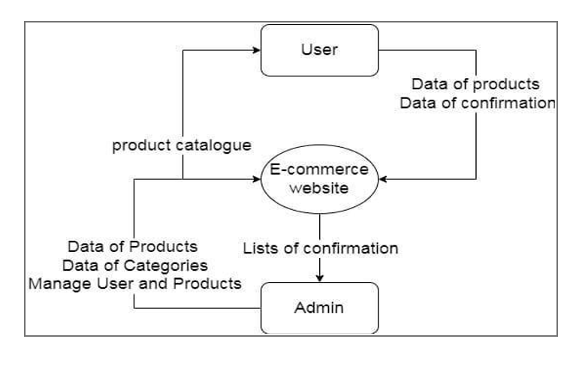

**3.4.1DFD-Diagram**

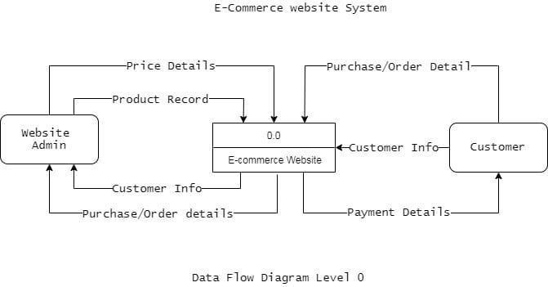

**3.5 Project Setup**

**3.5.1 Install Laravel**

Use Composer to create a new Laravel project

composer create-project --prefer-dist laravel/laravel ecommerce-daraz

Navigate to your project directory:

cd ecommerce-daraz

**3.1.2 Configure Database**

Set up your database connection in the `.env` file.

Migrate the database tables:

php artisan migrate

**3.5.1 Models and Migrations**

**Create Product Model and Migration**

Generate the model and migration files:

php artisan make:model Product -m

In the migration file, define product attributes (e.g., name, description, price).

**Create Order Model and Migration**

Generate the model and migration files:

php artisan make:model Order -m

In the migration file, define order attributes (e.g., user_id, total_price).

**3.5.2 Controllers**

**Generate Controllers**

Create controllers for managing products and orders:

php artisan make:controller ProductController

php artisan make:controller OrderController

**Implement CRUD Operations**

In `ProductController`, define methods for:

* Displaying a list of products.
* Showing individual product details.
* Creating a new product.
* Updating and deleting products.

**3.5.3 Routes**

**Set Up Web Routes**

* Define routes in the `routes/web.php` file.
* Connect routes to controller methods using Laravel's route system.

**3.5.4 Views and Blade Templates**

**Create Blade Templates**

Develop Blade templates for:

* Displaying a list of products (`products.blade.php`).
* Showing individual product details (`product_details.blade.php`).
* Creating a new product (`create_product.blade.php`).
* Managing orders (`orders.blade.php`).

**Implement Layouts**

* Create a master layout (`layout.blade.php`) that includes common elements like header, footer, and navigation.
* Extend this layout in your other Blade templates.

**3.5.5 Bootstrap Integration**

**Include Bootstrap**

Add Bootstrap to your project. You can use the CDN or download and include it locally in your project.

**Responsive Design**

* + Leverage Bootstrap's grid system to ensure a responsive layout.
  + Use Bootstrap classes for styling elements such as buttons, forms, and navigation.

**3.5.6 Custom CSS Styling**

**Create CSS Files**

* + Develop custom CSS files (e.g., `styles.css`) to enhance the appearance of your website.
  + Style specific elements, ensuring a cohesive and visually appealing design.

**3.5.7 Database Seeding**

**Seed Database**

* + Use Laravel's database seeding functionality to populate the database with sample data for testing.
  + Create seeders for products and orders.

**3.5.8 User Authentication**

**Implement User Authentication**

* + Set up user registration and login functionality using Laravel's built-in authentication features.
  + Create routes and views for user registration and login.

**3.5.9 Cart Functionality**

**Add to Cart**

* + Implement the ability to add products to the shopping cart.
  + Use Laravel Sessions to manage the cart data.

**Cart Display and Management**

* + Create a cart page to display the added products.
  + Allow users to update and remove items from the cart.
  + Implement logic to calculate and display the total price in the cart.

This detailed breakdown should guide you through each step of developing your e-commerce website using PHP Laravel, Bootstrap, and CSS. Feel free to refer to Laravel and Bootstrap documentation for more in-depth information on specific features and functionalities.

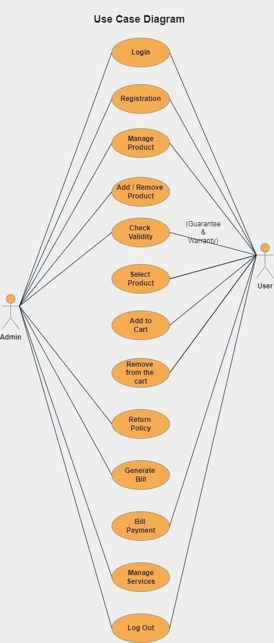

**Flow Chart Diagram**

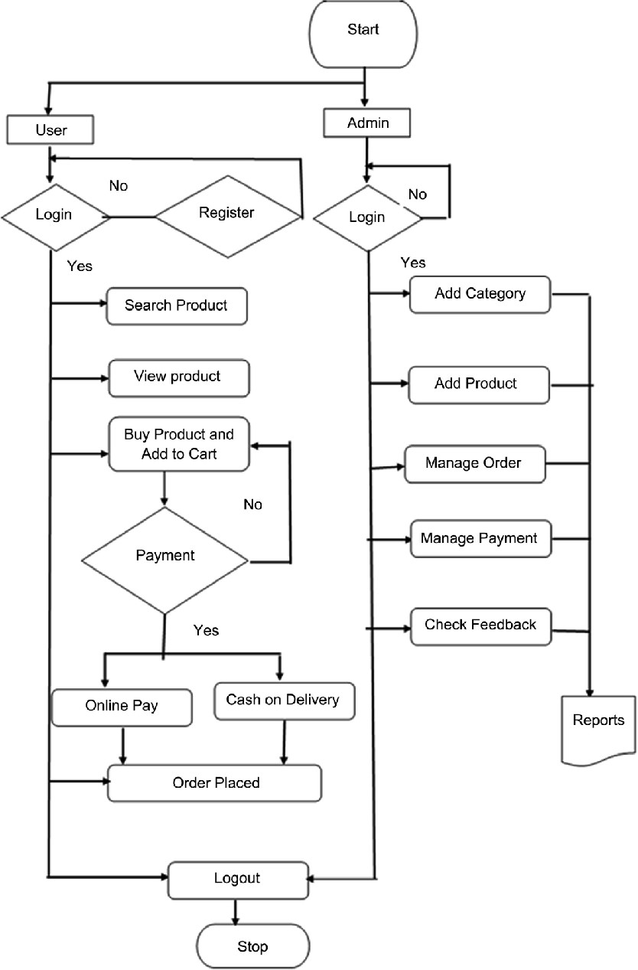

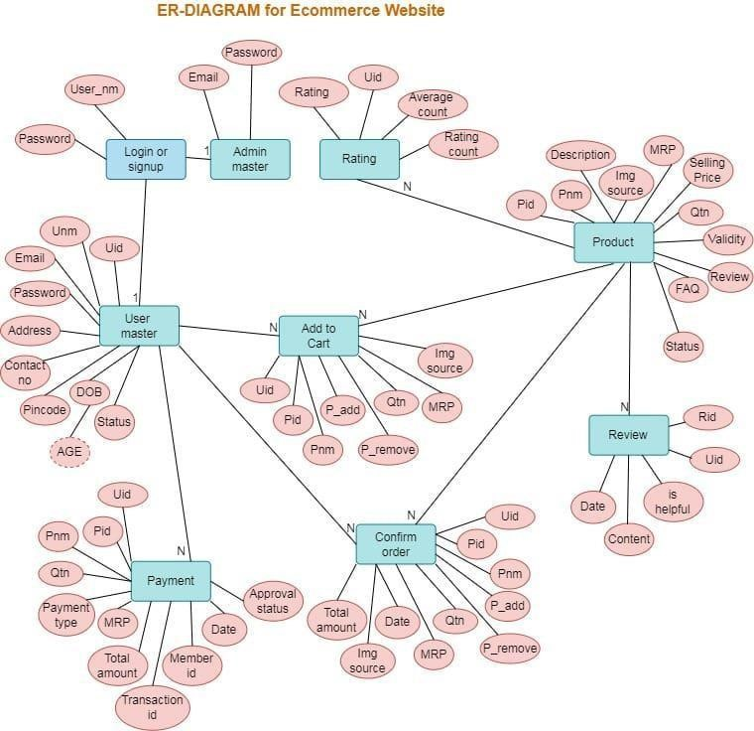

# **The Daraz Shopping Application**

**Final Outcome layout of Website**

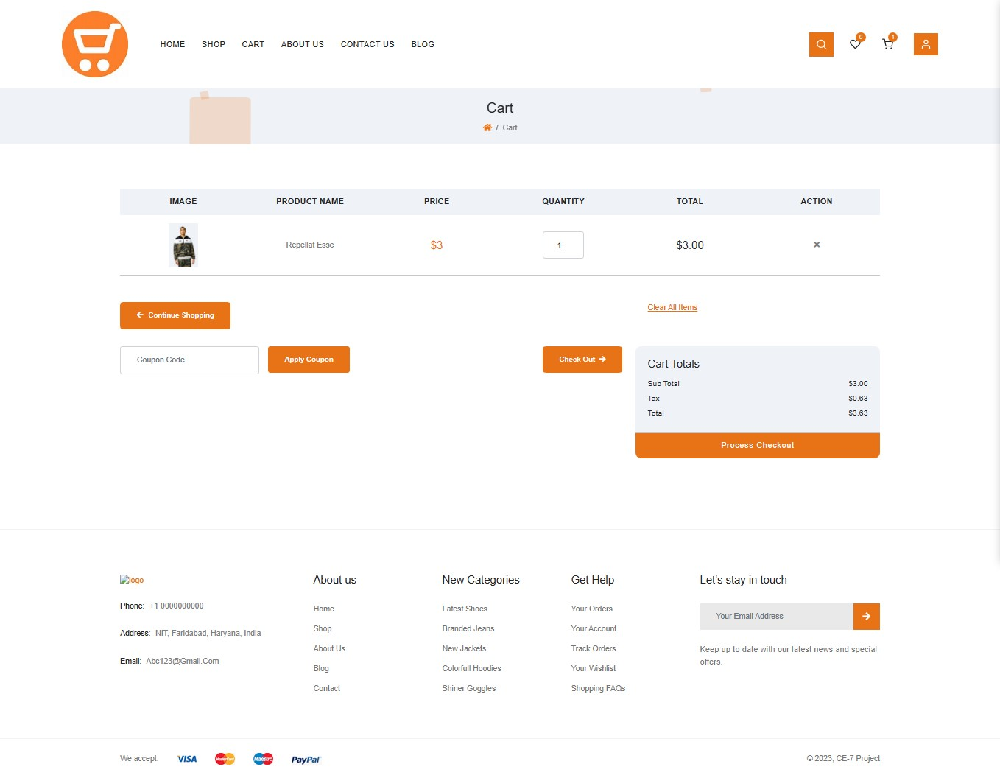

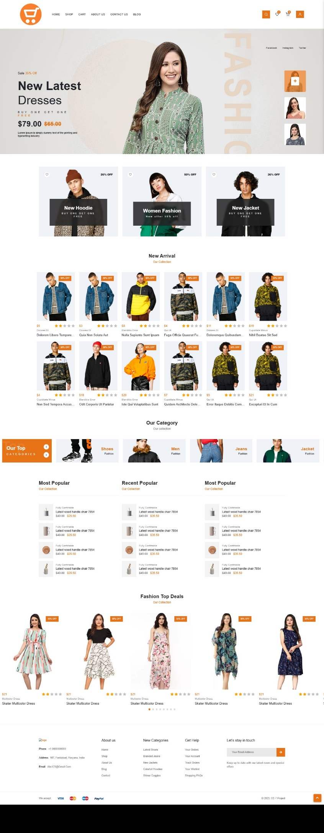

**Chapter 4**

**Requirement Specification**

Requirement Specification step is concerned with converting the output of the Requirement Analysis stage into a specification that reflects what the new system is required to do.

* 1. **Input Specification**

**4.1.1 Interface of the System**

The Interface of the System will be developed in International standard so that user should not to take moor time to be familiar with it. The system will organize under a MDI form and other forms will be the children SDI.

**4.1.2 Validation and Verification of data should giving**

Every input field will be under the Data Validation technique and after input of data another procedure will work for Data Verification. This two procedure will always alert to save the system from wrong data input.

**4.1.3 Minimize data redundancy**

Maximum unnecessary data from the main system will be redundant. Because this unnecessary data’s will keep more place and made the system chaos. So, some temp table will use in database for performing some tasks, after completing the task, all record will deleted automatically.

**4.1.5 Typing should be minimum**

To reduce moor typing the system will designed under relational database and form’s will use Combo boxes in some cases for not to type one thing again and again.

**4.1.6 Time efficient**

Obviously the system will time effective cause this is not a manual system. Same data for each branch will transfer with Floppy drive just by two clicks. Data from server will come in client also by clicking one menu button. So, it will really time efficient.

4.2 process specification

**4.2.1 Quickly and better service**

It is proven that a computer can work faster then a human. So there should not be any question that it will serve a quick service. When the whole system will in front of a user then it will easy to him to understand the system. A manual system could not give this facility. That’s mean it is obviously a better service.

**Find utility**

The system will use a powerful find utility for finding data easily. User could be able to use separate kinds of data to find a record like Member ID, Supplier ID, Product ID etc.

**4.2.2 Easy menu system**

The system will maintain all possible International rules of development, so it should use an easy menu system to access any form easily.

**4.2.3 Security**

Log In system will very strong in the system. Each user of the system will have their own password and that password will given by Admin of the system. They will also able to change their password. But Admin will able to always restrict their login and change access permission.

**4.2.4 Error message**

In any unseen bug will caught in the system then the system will show an Error Message.

Output Specification

Presentation should be nice

One better system can fall down it the system comes boring in some days. Again in the age of multimedia user would not like to use an ordinary system. So presentation of the system should be better and it will do on the system.

**4.2.5 Quickly available**

The system will be tried to give the facility to access data as quickly as possible.

**4.3 General Specification**

**User friendly**

To make the system user friendly the menus of the system will divide into separate parts like Reception menu, Product menu, Report menu on Server etc.

**Uses of Short Cut Key**

The forms of the system will link under short cut keys. So user will be able to use short cut keys to go straight in another form.

**Chapter 5**

**Software Design**

The online shopping system with card recharge accepts input from users and generates dynamic displays of required output or data sources. To do this, following tools and technologies are used.

* HTML
* PHP
* MySQL
* HTTP
* Laravel
* Bootstrap
* jQuery
* JavaScript

**5.3 Testing and Debugging**

Software testing is the process of testing software in a controlled manner to ensure that it behaves the way it is expected to behave. Software testing is, thus a critical element of software quality assurance. Testing requires that the developer discards preconceived notices of the correctness of the software just developed and overcome the conflict of interest that occurs when errors are revealed.

# **Conclusion**

In conclusion, this project has successfully addressed the dynamic landscape of electronic shopping by providing a user-friendly and interactive e-commerce website for purchasing online. The selection of Microsoft's Internet Information Services (IIS) as the web server and MySQL as the backend database has proven effective in creating a robust and efficient web application. The incorporation of ADO.NET for database interactions, with its in-memory caching capabilities, has contributed to the optimization of data access and processing.

The project's emphasis on a well-designed shopping cart, accompanied by user-friendly application logic, ensures a seamless experience for customers. Features such as easy cart navigation, item addition, and removal have been implemented to enhance user comfort.

Through the development process, a comprehensive understanding of ASP.NET for web development, database connectivity with ADO.NET, and the intricacies of building a user-friendly shopping cart application has been gained. The project's design, encompassing both the Data Model and Process Model, elucidates how the database is structured with various tables and how data is accessed and processed.

In essence, this project has not only provided valuable insights into the creation of an interactive web page but has also equipped with a nuanced understanding of the technologies employed. The fusion of a well-designed website, efficient database connectivity, and user-centric features positions this e-commerce platform to meet the evolving needs of online shoppers and contribute positively to the realm of electronic commerce.

# 

# **Bibliography**

###### Articles

1. Chen, L. (2000). Enticing Online Consumers: A Technology Acceptance Perspective Research-in-Progress. *ACM Proceedings, SIGCPR*.
2. Diwakar, H., Marathe, M. (2000). The architecture of a one-stop web-window shop. December, *ACM SIGecom Exchanges*, Volume 2 Issue 1.
3. Morrison, M., Morrison, J., and Keys, A. (2002). Integrating Web Sites and Databases*.* *Communications of the ACM*, September, Volume 45, Issue 9.
4. Kubilus, N. J. (2000). Designing an e-commerce site for users. September 2000, *Crossroads*, Volume 7 Issue 1.
5. Norman, D.A. TheDesign of Everyday Things. *Doubleday*, New York, 1994.
6. Tilson, R., Dong, J., Martin, S., Kieke, E. (1998). A comparison of two current ecommerce sites. September, *Proceedings of the 16th annual international conference on Computer documentation*.

###### **References**

1. http://encyclopedia.laborlawtalk.com/IIS for information on IIS
2. http://aspnet.4guysfromrolla.com/articles/020404-1.aspx for relationship between IIS and ASP.NET.
3. http://216.15.201.66/dpec/course.htm?fullpg=http%3A//216.15.201.66/dpec/cours es/wac312/wah006.htm&acro=wac312 for security authentication in ASP.NET
4. http://samples.gotdotnet.com/quickstart/aspplus/doc/mtstransactions.aspx for information on Transactions in ASP.NET.
5. http://www.x-cart.com/articles/design_development.htmlfor online customer behavior.
6. http://aspnet.4guysfromrolla.com/articles/011404-1.aspx for relation between IIS and ASP.NET.
7. http://www.informatik.uni-bremen.de/uniform/gdpa_d/methods/m-fctd.htm for definition of Functional Decomposition.
8. http://www.agilemodeling.com/artifacts/dataFlowDiagram.htm for definition of Data Flow Diagram.
9. http://www.startvbdotnet.com/ado/default.aspx for information on ADO.NET
10. http://mypage.iusb.edu/~hhakimza/505/index.html for ADO.NET objects.
11. http://msdn.microsoft.com for ADO.NET objects.